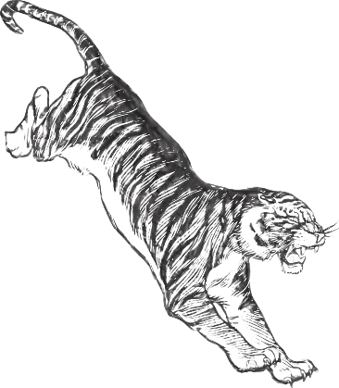
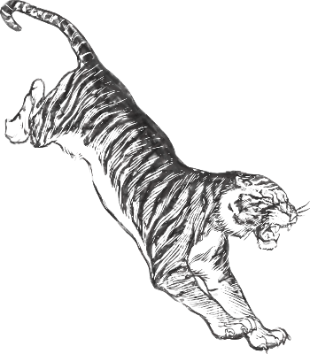
2023 Middle School
Date | Opponent | Home/Away | Time (CST)
Monday, February 13th | Franklin County | Away | 4:30
Thursday, February 16th | Tolar | Away | 3:00
Friday, February 17th | PSJ | Away | 4:00
Tuesday, February 21st | Cottondale DH  Girls Only | Away | 5:00 & 7:00
Tuesday, February 21st | Wewa  Boys Only | Home | 4:00
Thursday, February 23rd | Franklin County | Home | 1:00 MS, 3:00 JV, 5:00V
Friday, February 24th | Grandridge | Away | 4:00
Monday, February 27th | PSJ | Home | 4:00
Tuesday, February 28th | Hosford | Home | 4:00
Thursday, March 2nd | Hosford | Away | 3:00
Monday, March 6th | Tolar | Home | 4:00
Tuesday, March 7th | Wewa | Away | 4:00
Thursday, March 9th | Marianna | Away | 4:30 (Bteam First)
Monday, March 13th | Wewa  Girls only | Home | 6:00
Baseball/Softball Schedule
Baseball HC: Porter Smith Principal: Tracy Wood
Baseball AC: Travis Smith Asst. Principal: Link Barber
Softball HC: Ellen Watson Asst. Principal: Amanda Dehn
Softball AC: MS AD: Emory Horne

